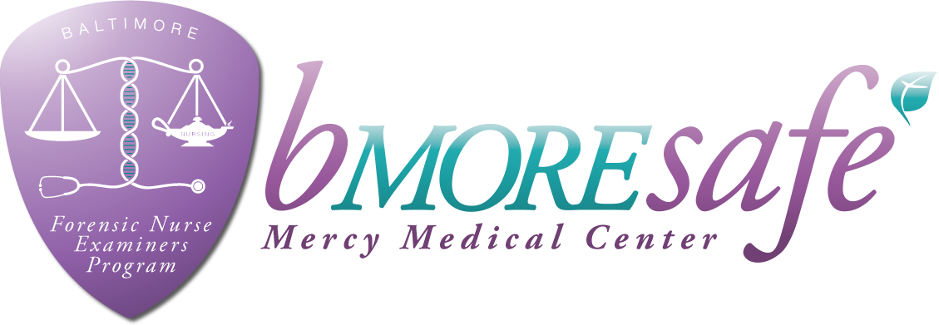

**Forensic Nurse Examiner Training – Adult & Adolescent**

**View the FNE program online:** [www.bmoresafemercy.org](http://www.bmoresafemercy.org) **&**  **Mercy Forensic Nurse Examiners – bmoresafe**

**March 12th & 13th, 2019 (8am- 4:30pm/Classroom)**

Twenty-Four hours online training to be completed prior to classroom training

**\*\*\*FUTURE DATES IN 2019: August 7th & 8th; November 6th & 7th\*\*\***

**Truman Semans Conference Room**

**Weinberg Center for Women’s Health & Medicine at MMC**

**227 Saint Paul Place, Baltimore, Maryland 21202**

**$350 course fee includes:**

**All course materials**

**16** **hours didactic and 24 hours online web based training by nationally-recognized forensic nursing instructors & local criminal justice agencies**

**Maryland Board of Nursing approved 40 CEUs**

|  |
| --- |
| **Send registration below to: Mercy Medical Center FNE Program**  **Payment to:**  **PAYPAL ACCOUNT:** [**Mercysafe@gmail.com**](mailto:Mercysafe@gmail.com)  **If using PayPal cost is $360**  Or mail check payable to: Mercy Forensic Department  or money order to: MMC c/o Debra Holbrook, 301 St. Paul Place, Baltimore, MD 21202  For questions or concerns regarding this training, please e-mail: **ccooley@mdmercy.com**  Name: ____________________________________________________________________________________  Affiliation: ________________________________________________________________________________  Address: __________________________________________________________________________________  Telephone: ____________________________________________ Email:________________________________________________  How did you hear about our program? ___________________________________________________________ |
| ***The MNA is accredited as an approver of continuing nursing education by the American Nurses Credentialing Centers Commission on Accreditation.***  ***The Mercy FNE Program does not refund registration fees for any reason. *** |